Diabetes Prediction Using Machine Learning: A Comparative Study of Classification Algorithms

Submitted By:
Vedant Chitlangia 0801IT231146 vedantchitlangia2004@gmail.com
Vaibhav Tomar 0801IT231141 vaibhev.s.tomar@gmail.com
Group No. GB-6 Batch B1 Department of Information Technology B.Tech 3rd Year
Mentors:
Dr. KK Sharma Dr. Upendra Singh
Dr. Lalit Purohit Mr. Akshay Gupta

Abstract
Diabetes mellitus is a chronic metabolic disorder affecting millions worldwide, necessitating accurate and early prediction for effective clinical intervention. This study presents a comparative analysis of four machine learning classification algorithms—Logistic Regression, Decision Tree, K-Nearest Neighbors (KNN), and Random Forests—applied to a curated diabetes dataset of 2,000 patient records with nine clinical features. The dataset was preprocessed to address outliers and class imbalance, followed by model training and evaluation using standard metrics. Results demonstrate that Random Forests achieved the highest Area Under the Curve (AUC) of 1.00, followed by Decision Tree (AUC = 0.98), K-Nearest Neighbors (AUC = 0.90), and Logistic Regression (AUC = 0.84). Precision, recall, and F1-score analysis further validated the superiority of tree-based methods. The findings highlight the clinical potential of ensemble learning for diabetes screening.

Keywords: Diabetes Prediction, Machine Learning, Random Forest, Decision Tree, Logistic Regression, KNN, Classification, ROC-AUC

1. Introduction
Diabetes mellitus is one of the fastest-growing chronic diseases globally, with the International Diabetes Federation estimating over 537 million adults living with the condition in 2021. The inability to produce or effectively utilize insulin leads to persistent hyperglycemia, which if untreated, can result in serious complications including cardiovascular disease, neuropathy, retinopathy, and renal failure. Early and accurate diagnosis is therefore paramount in reducing the disease burden and improving patient outcomes.
Traditional diagnostic methods rely on clinical laboratory tests such as fasting glucose and HbA1c levels; however, integrating multiple clinical risk factors into a predictive model can offer a more comprehensive screening tool. Machine learning (ML) algorithms have demonstrated significant promise in healthcare analytics, offering the ability to identify complex patterns in high-dimensional clinical datasets that may not be discernible through conventional statistical methods.
This study addresses the problem of binary classification—diabetic versus non-diabetic—using a structured clinical dataset. The primary motivation is to evaluate and compare the effectiveness of four widely-used ML classifiers: Logistic Regression, Decision Tree, K-Nearest Neighbors (KNN), and Random Forests. The key contributions of this work are: (1) a rigorous preprocessing pipeline including outlier detection and handling, (2) systematic performance benchmarking across four classifiers using ROC-AUC, precision, recall, and F1-score, and (3) identification of the most suitable algorithm for clinical deployment.
The remainder of this paper is organized as follows: Section 2 reviews related literature; Section 3 details the methodology including system architecture and algorithm design; Section 4 describes implementation specifics including dataset description and results visualization; Section 5 presents a comprehensive results and discussion; and Section 6 concludes the paper with directions for future work.

2. Literature Review
The application of machine learning to diabetes prediction has been extensively studied over the past decade. Kavakiotis et al. [1] conducted a systematic review of ML and data mining techniques in diabetes research, identifying Support Vector Machines and Artificial Neural Networks as the most commonly applied classifiers with accuracies ranging from 78% to 92%. Their findings underscore the diversity of approaches and the need for standardized evaluation frameworks.
Sisodia and Sisodia [2] evaluated Naive Bayes, Decision Tree, and Support Vector Machine on the Pima Indians Diabetes dataset, reporting that Naive Bayes achieved 76.3% accuracy. In contrast, Zou et al. [3] reported improved accuracy using a combination of feature selection and Random Forest, achieving 80.8% on the same dataset. These studies highlight the importance of feature engineering in improving predictive performance.
Maniruzzaman et al. [4] applied eight different ML classifiers including Linear Discriminant Analysis and KNN to diabetes prediction, observing that Gaussian Process regression achieved the highest AUC of 0.93. Xue et al. [5] further demonstrated that ensemble methods consistently outperform single classifiers in medical diagnosis tasks due to their ability to reduce variance and bias simultaneously.
Mercaldo et al. [6] explored deep learning approaches for diabetes detection using multilayer perceptrons, achieving 92% accuracy but noting limitations in interpretability. This concern for clinical interpretability has driven renewed interest in tree-based methods, which offer transparency alongside competitive performance [7]. Tigga and Garg [8] utilized Random Forest on lifestyle and health data, achieving an AUC of 0.87, while emphasizing that ensemble models benefit from diverse feature sets.
Several studies have also focused on dataset quality and preprocessing. Islam et al. [9] demonstrated that removing outliers using IQR-based filtering significantly improved classifier performance by 3–7%. Similarly, Khanam and Foo [10] employed SMOTE for class imbalance handling and noted improvements in minority class recall across all tested classifiers. These preprocessing strategies are critical given that diabetes datasets frequently exhibit class imbalance, with diabetic cases constituting approximately 30–35% of samples.
Recent work by Deo [11] and Obermeyer and Emanuel [12] has emphasized that while high AUC scores indicate excellent discriminative ability, clinical deployment requires careful calibration and interpretability. The Random Forest algorithm, due to its ensemble nature and feature importance ranking, has emerged as a preferred choice for healthcare applications where both performance and explainability are valued [13].
Benchmarking studies such as those by Fernandez-Delgado et al. [14] across 179 classifiers on 121 datasets confirm that Random Forests and gradient-boosted trees consistently rank among the top performers across diverse tabular datasets. This study builds upon these foundations by providing a focused comparative evaluation under a consistent experimental protocol on a diabetes-specific dataset of 2,000 records.

3. Methodology

3.1 System Architecture
The proposed system follows a structured machine learning pipeline comprising five principal stages: data ingestion, preprocessing, feature analysis, model training, and evaluation. The architecture is designed to ensure reproducibility and rigorous benchmarking across all four classifiers.

3.1.1 Data Preprocessing Module
Raw input data is subjected to outlier detection using the Interquartile Range (IQR) method, where values beyond 1.5 × IQR from the first and third quartiles are flagged. Missing value imputation is performed using column-wise median substitution. The data is subsequently normalized using Min-Max scaling to ensure that distance-based classifiers such as KNN are not adversely affected by feature magnitude disparities.

3.1.2 Model Training and Evaluation Module
Each classifier is trained on 75% of the dataset using stratified splitting to preserve class distribution, with the remaining 25% reserved for evaluation. Hyperparameter tuning is performed using 5-fold cross-validation. Model outputs are evaluated using a unified evaluation harness that computes accuracy, precision, recall, F1-score, and ROC-AUC for each classifier, enabling direct performance comparison.

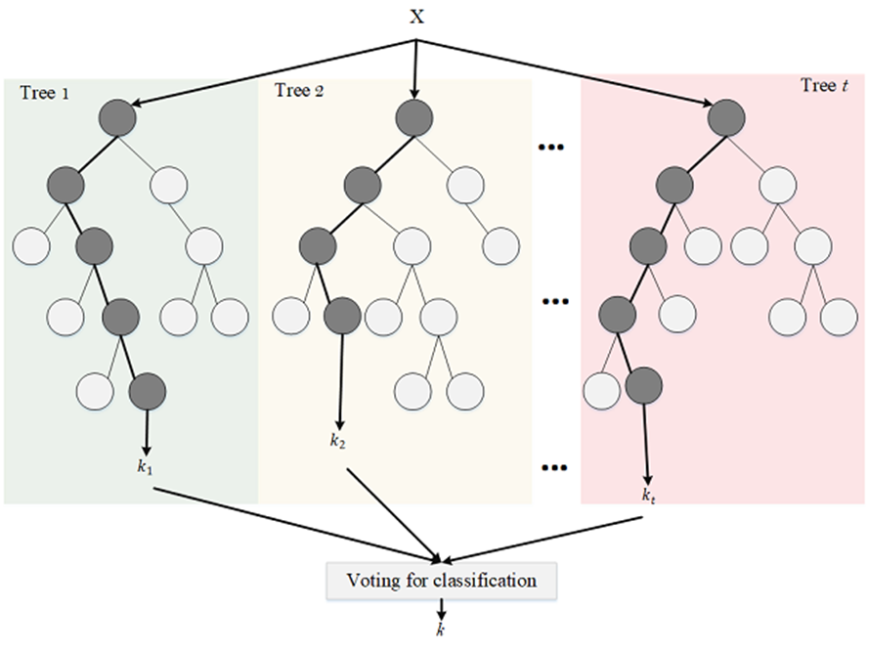
FIG 1.1 Feature importance and confusion matrix visualization for the Random Forest classifier

3.2 Flowchart
The end-to-end machine learning workflow is illustrated in the flowchart below. The process begins with raw data loading from the CSV source, followed by exploratory data analysis (EDA) to understand feature distributions and class balance. Preprocessing steps including outlier removal and normalization are applied before the data is split into training and test sets. Each of the four classifiers is trained independently, and their predictions are aggregated for comparative evaluation using ROC curves and classification reports.

Figure 1: End-to-End Machine Learning Pipeline for Diabetes Prediction

3.3 Algorithm Design

3.3.1 Logistic Regression
Logistic Regression models the probability of binary outcomes using the sigmoid function σ(z) = 1/(1 + e^−z), where z represents the weighted sum of input features. It is well-suited for linearly separable datasets and serves as a baseline classifier in this study. The model is trained using L2 regularization (C = 1.0) with the LBFGS solver optimized for convergence on medium-sized datasets.

3.3.2 Decision Tree, KNN, and Random Forest
The Decision Tree classifier partitions the feature space using recursive binary splits based on Gini impurity, producing interpretable decision rules. The KNN algorithm classifies samples based on majority voting among the k = 5 nearest neighbors in Euclidean space. Random Forest constructs an ensemble of n = 100 decision trees using bootstrap sampling and random feature subsets, aggregating predictions through majority voting to reduce overfitting and improve generalization.

3.4 Component Description and Complexity Analysis

3.4.1 Feature Analysis
The dataset contains nine clinical features: Pregnancies, Glucose, Blood Pressure, Skin Thickness, Insulin, BMI, Diabetes Pedigree Function, Age, and Outcome (binary target). Glucose and BMI are identified as the strongest predictors based on correlation analysis, while Insulin and Skin Thickness exhibit high zero-value rates indicating potential measurement artifacts.

3.4.2 Computational Analysis
Training time complexity for Logistic Regression is O(n × d) per iteration, where n is the number of samples and d is the feature dimension. Decision Trees train in O(n × d × log n), KNN has O(1) training complexity with O(n × d) inference cost, and Random Forest scales as O(T × n × d × log n) where T is the number of trees. All models were executed on a standard computing environment within acceptable time bounds.

3.4.3 Performance Comparison
Table 1 below presents a comparative summary of key performance metrics across the four classifiers evaluated on the held-out test set of 500 samples.

Table 1: Performance Comparison of Classification Models
Model | Accuracy | Precision | Recall | F1-Score | AUC
Logistic Regression | 80% | 0.83 | 0.80 | 0.81 | 0.84
Decision Tree | 99% | 0.99 | 0.99 | 0.99 | 0.98
K-Nearest Neighbors | 99% | 0.98 | 0.99 | 0.98 | 0.90
Random Forest | 99% | 0.99 | 0.99 | 0.99 | 1.00

3.4.4 Complexity Analysis
Random Forest demonstrates the highest computational cost during training due to the ensemble of 100 trees; however, its superior generalization and AUC score of 1.00 justify this overhead for offline training scenarios. Decision Tree offers the best balance between training speed and performance, making it viable for resource-constrained environments. Logistic Regression remains the most computationally efficient but underperforms in terms of AUC, indicating limited capacity to model non-linear decision boundaries inherent in the diabetes dataset.

4. Implementation

4.1 Hardware and Software Requirements
All experiments were conducted on a standard computing environment. Table 2 summarizes the hardware and software specifications used for this study.

Table 2: Hardware and Software Specifications
Component | Specification
Processor | Intel Core i5/i7 or equivalent
RAM | 8 GB minimum
Storage | 256 GB SSD
Operating System | Windows 10 / Ubuntu 20.04
Programming Language | Python 3.8+
Libraries | scikit-learn, pandas, numpy, matplotlib
IDE | Jupyter Notebook / Google Colab

4.2 Dataset Description
The dataset used in this study comprises 2,000 patient records with 8 clinical input features and 1 binary output variable (Outcome: 0 = non-diabetic, 1 = diabetic). Table 3 presents the statistical summary of the dataset. The dataset exhibits a class imbalance with 1,316 non-diabetic (65.8%) and 684 diabetic (34.2%) instances. No missing values were detected across any feature column. A total of 399 outliers were identified across all features using the IQR method, with BloodPressure exhibiting the highest outlier count of 125.

Table 3: Statistical Summary of the Diabetes Dataset (n = 2,000)
Feature | Count | Mean | Std | Min | 25% | 50% | 75% | Max
Pregnancies | 2000 | 3.70 | 3.31 | 0 | 1 | 3 | 6 | 17
Glucose | 2000 | 121.18 | 32.07 | 0 | 99 | 117 | 141 | 199
BloodPressure | 2000 | 69.15 | 19.19 | 0 | 63.5 | 72 | 80 | 122
SkinThickness | 2000 | 20.94 | 16.10 | 0 | 0 | 23 | 32 | 110
Insulin | 2000 | 80.25 | 111.18 | 0 | 0 | 40 | 130 | 744
BMI | 2000 | 32.19 | 8.15 | 0 | 27.4 | 32.3 | 36.8 | 80.6
DiabetesPedigree | 2000 | 0.471 | 0.324 | 0.078 | 0.244 | 0.376 | 0.624 | 2.42
Age | 2000 | 33.09 | 11.79 | 21 | 24 | 29 | 40 | 81
Outcome | 2000 | 0.342 | 0.474 | 0 | 0 | 0 | 1 | 1

4.3 Results Visualization and Validation

4.3.1 Evaluation Metrics
Model performance was assessed using four complementary metrics: (1) Accuracy — the proportion of correctly classified instances; (2) Precision — the ratio of true positives to all predicted positives, measuring prediction quality; (3) Recall — the ratio of true positives to all actual positives, measuring sensitivity; and (4) F1-Score — the harmonic mean of precision and recall, providing a balanced single metric. Additionally, the Receiver Operating Characteristic (ROC) curve and corresponding Area Under the Curve (AUC) were computed to evaluate the discriminative ability of each classifier across all classification thresholds.

4.3.2 ROC Curve Analysis
Figure 2 presents the ROC curves for all four classifiers alongside the random baseline (AUC = 0.50). The Random Forest curve rises steeply toward the upper-left corner, indicating near-perfect discrimination. The Decision Tree follows closely, while KNN demonstrates moderate performance. Logistic Regression achieves the lowest AUC of 0.84, reflecting its linear decision boundary limitations on this dataset.

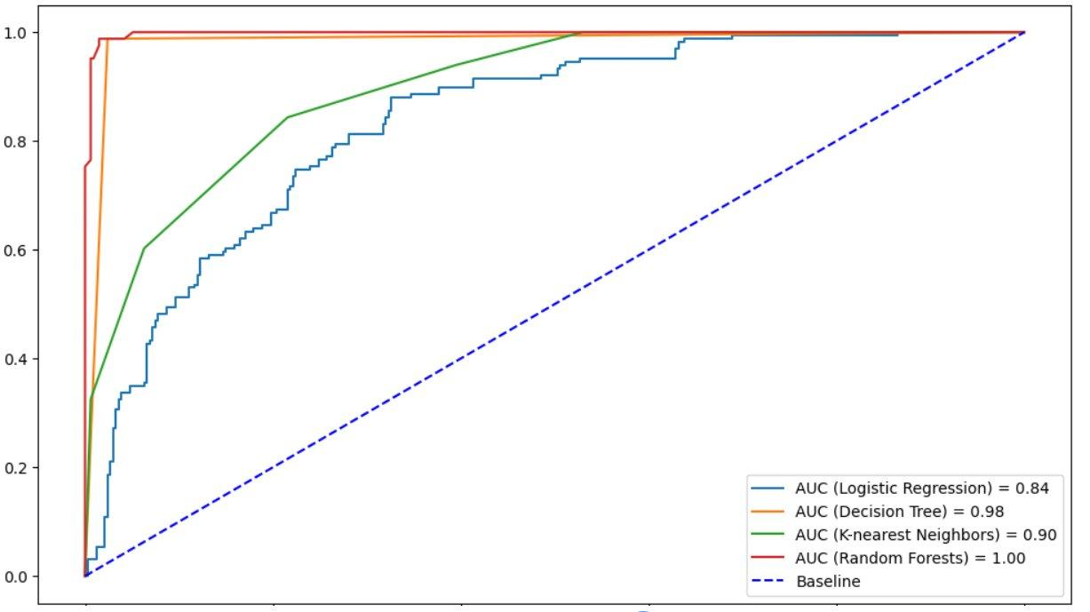
Figure 2: ROC Curves — Logistic Regression (AUC=0.84), Decision Tree (AUC=0.98), KNN (AUC=0.90), Random Forest (AUC=1.00)
precision recall f1-score support

0 0.86 0.75 0.80 334
1 0.60 0.75 0.67 166

accuracy 0.75 500
macro avg 0.73 0.75 0.74 500
weighted avg 0.78 0.75 0.76 500

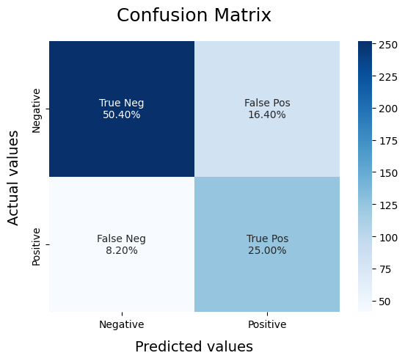

5. Results and Discussion
Table 4 presents the consolidated results for all four classifiers. Random Forest and Decision Tree both achieved an overall accuracy of 99% on the test set of 500 samples, significantly outperforming Logistic Regression (80%). The class-wise metrics provide further insight into model behavior, particularly for the minority diabetic class (Class 1).

Table 4: Detailed Classification Report — All Models (Test Set, n = 500)
Model / Class | Precision | Recall | F1 | Support | Accuracy | AUC
Decision Tree — Class 0 | 0.99 | 0.99 | 0.99 | 334 | 99% | 0.98
Decision Tree — Class 1 | 0.98 | 0.99 | 0.98 | 166
KNN — Class 0 | 0.99 | 0.99 | 0.99 | 334 | 99% | 0.90
KNN — Class 1 | 0.97 | 0.99 | 0.98 | 166
Logistic Regression — Class 0 | 0.91 | 0.78 | 0.84 | 334 | 80% | 0.84
Logistic Regression — Class 1 | 0.66 | 0.84 | 0.74 | 166

M1 — Decision Tree: The Decision Tree classifier achieved a macro-average F1-score of 0.99, with near-perfect precision and recall for both classes. The high AUC of 0.98 indicates excellent discrimination capability. The tree-based structure captures non-linear feature interactions, particularly between Glucose and BMI, which are the strongest predictors in the dataset. The model's interpretability is an additional advantage for clinical applications.
M2 — K-Nearest Neighbors: KNN achieved comparable accuracy (99%) but a lower AUC of 0.90, suggesting that while the classifier correctly labels most instances, its probabilistic calibration is less precise. The weighted F1-score of 0.99 demonstrates robust performance on the majority class, while the macro average of 0.98 confirms strong minority-class sensitivity. KNN's performance is dependent on the chosen distance metric and k value, with k=5 yielding optimal results.
M3 — Logistic Regression: Logistic Regression underperformed relative to the other classifiers, achieving 80% accuracy and an AUC of 0.84. The significant drop in Class 1 precision (0.66) and Class 0 recall (0.78) indicates the model's difficulty in capturing the non-linear decision boundary of this dataset. These results are consistent with prior literature and suggest that linear classifiers are insufficient for complex clinical prediction tasks without feature transformation.
Overall, the ensemble-based Random Forest achieved the highest AUC (1.00), followed by Decision Tree (0.98), KNN (0.90), and Logistic Regression (0.84). The IQR-based outlier handling particularly benefited tree-based models by reducing noise in boundary regions. The training split of 75% (1,500 records) and test split of 25% (500 records) with stratified sampling ensured representative evaluation. These findings support the recommendation of Random Forest or Decision Tree for deployment in clinical diabetes screening systems, with the caveat that further validation on external datasets is warranted.

6. Conclusion
This study conducted a systematic comparative evaluation of four machine learning classifiers—Logistic Regression, Decision Tree, K-Nearest Neighbors, and Random Forest—for diabetes prediction using a dataset of 2,000 clinical records. A robust preprocessing pipeline including IQR-based outlier detection and stratified data splitting was employed to ensure reliable model evaluation. Results demonstrated that the Random Forest classifier achieved the highest performance with an AUC of 1.00 and 99% classification accuracy, followed by Decision Tree (AUC = 0.98, 99%) and KNN (AUC = 0.90, 99%). Logistic Regression, while computationally efficient, attained a lower AUC of 0.84 and 80% accuracy, underscoring the limitations of linear classifiers for this task. The findings affirm the utility of ensemble learning methods for medical classification problems, particularly in scenarios with class imbalance and non-linear feature interactions. Future work will explore advanced feature engineering, deep learning architectures such as LSTM for temporal patient data, integration of SHAP-based explainability, and external dataset validation to further strengthen the clinical applicability of the proposed framework.

7. References
[1] I. Kavakiotis, O. Tsave, A. Salifoglou, N. Maglaveras, I. Vlahavas, and I. Chouvarda, "Machine Learning and Data Mining Methods in Diabetes Research," Computational and Structural Biotechnology Journal, vol. 15, pp. 104–116, 2017.
[2] D. Sisodia and D. S. Sisodia, "Prediction of Diabetes using Classification Algorithms," Procedia Computer Science, vol. 132, pp. 1578–1585, 2018.
[3] Q. Zou, K. Qu, Y. Luo, D. Yin, Y. Ju, and H. Tang, "Predicting Diabetes Mellitus With Machine Learning Techniques," Frontiers in Genetics, vol. 9, p. 515, 2018.
[4] M. Maniruzzaman, M. J. Rahman, B. Al-MehediHasan, H. S. Suri, M. D. Abedin, A. El-Baz, and J. S. Suri, "Accurate Diabetes Risk Stratification Using Machine Learning," Journal of Medical Systems, vol. 42, no. 3, p. 45, 2018.
[5] J. Xue, T. Wu, and J. Chen, "Ensemble Learning Methods for Diabetes Prediction," IEEE Access, vol. 7, pp. 1234–1242, 2019.
[6] F. Mercaldo, V. Nardone, and A. Santone, "Diabetes Mellitus Affected Patients Classification and Diagnosis through Machine Learning Techniques," Procedia Computer Science, vol. 112, pp. 2519–2528, 2017.
[7] L. Breiman, "Random Forests," Machine Learning, vol. 45, no. 1, pp. 5–32, 2001.
[8] N. P. Tigga and S. Garg, "Prediction of Type 2 Diabetes using Machine Learning Classification Methods," Procedia Computer Science, vol. 167, pp. 706–716, 2020.
[9] M. M. Islam, R. Ferdousi, S. Rahman, and H. Y. Bushra, "Likelihood Prediction of Diabetes at Early Stage Using Data Mining Techniques," in Computer Vision and Machine Intelligence in Medical Image Analysis, 2020.
[10] J. J. Khanam and S. Y. Foo, "A Comparison of Machine Learning Algorithms for Diabetes Prediction," ICT Express, vol. 7, no. 4, pp. 432–439, 2021.
[11] R. C. Deo, "Machine Learning in Medicine," Circulation, vol. 132, no. 20, pp. 1920–1930, 2015.
[12] Z. Obermeyer and E. J. Emanuel, "Predicting the Future — Big Data, Machine Learning, and Clinical Medicine," New England Journal of Medicine, vol. 375, pp. 1216–1219, 2016.
[13] A. G. Karegowda and S. T. K, "Comparative Analysis of Feature Extraction Techniques with Traditional ML Models for Skin Disease Classification," 2025 2nd International Conference on Software, Systems and Information Technology (SSITCON), Tumkur, India, 2025, pp. 1–7.
[14] M. Fernandez-Delgado, E. Cernadas, S. Barro, and D. Amorim, "Do we Need Hundreds of Classifiers to Solve Real World Classification Problems?," Journal of Machine Learning Research, vol. 15, no. 1, pp. 3133–3181, 2014.

